**Table S1.** Hydrogen bonding between MEV-Fc-TLR2 complexes

|  |  |  |  |
| --- | --- | --- | --- |
| Number | Structure 1 | Distance | Structure 2 |
| 1 | A: THR 65[OG1] | 2.72 | B: ARG 183[NH2] |
| 2 | A: GLY 87[O] | 2.66 | B: ARG 183[NH2] |
| 3 | A: ASN 89[OD1] | 2.62 | B: ARG 183[NH1] |
| 4 | A: ASN 89[OD1] | 3.07 | B: ARG 183[NH2] |
| 5 | A: ASN 89[ND2] | 2.95 | B: GLU 186[OE2] |
| 6 | A: TYR 111[OH] | 3.05 | B: GLU 150[OE2] |
| 7 | A: TYR 111[OH] | 2.98 | B: GLY 153[N] |
| 8 | A: ASP 160[O] | 2.53 | B: LYS 149[NZ] |
| 9 | A: ASP 160[OD1] | 2.71 | B: LYS 149[NZ] |
| 10 | A: ASP 160[OD1] | 2.79 | B: ARG 202[NH2] |
| 11 | A: ASP 160[OD2] | 2.93 | B: PHE 148[N] |
| 12 | A: THR 161[OG1] | 2.87 | B: LYS 149[O] |
| 13 | A: ASP 185[OD2] | 2.63 | B: LYS 149[NZ] |
| 14 | A: LYS 208[NZ] | 2.59 | B: TYR 145[OH] |
| 15 | A: LYS 208[NZ] | 2.67 | B: TYR 197[OH] |
| 16 | A: ASP 231[O] | 2.69 | B: TYR 197[OH] |
| 17 | A: ARG 321[O] | 2.78 | B: THR 91[OG1] |
| 18 | A: ARG 321[NE] | 3.04 | B: TYR 95[OH] |
| 19 | A: ARG 321[NH1] | 2.99 | B: HIS 165[NE2] |
| 20 | A: ARG 321[NH2] | 2.69 | B: TYR 95[OH] |
| 21 | A: ARG 321[NH2] | 2.83 | B: HIS 165[NE2] |
| 22 | A: LYS 347[NZ] | 2.54 | B: TYR 47[OH] |
| 23 | A:LYS 348[NZ] | 2.52 | B: ASP 88[OD2] |

**Table S2.** Hydrogen bonding between MEV-Fc-TLR4 complexes

|  |  |  |  |
| --- | --- | --- | --- |
| Number | Structure 1 | Distance | Structure 2 |
| 1 | A: GLN 39[NE2] | 2.97 | B: PRO 167[O] |
| 2 | A: MET 41[O] | 2.72 | B: LYS 62[NZ] |
| 3 | A: GLU 42[O] | 2.64 | B: LYS 62[NZ] |
| 4 | A: ASP 84[OD2] | 2.8 | B: HIS 168[ND1] |
| 5 | A: LYS 153[ND] | 2.58 | B: GLU 112[OE2] |
| 6 | A: HIS 159[ND1] | 2.91 | B: GLU 99[OE2] |
| 7 | A: GLU 178[OE2] | 3.01 | B: GLU 112[N] |
| 8 | A: SER 184[OG] | 3.31 | B: HIS 103[NE2] |
| 9 | A: SER 184[OG] | 3.31 | B: HIS 103[NE2] |
| 10 | A: ARG 234[NH2] | 2.79 | B: GLU 201[OE2] |
| 11 | A: ARG 289[NH1] | 2.7 | B: GLU 201[O] |
| 12 | A: ARG 289[NH1] | 2.74 | B: ARG 202[O] |
| 13 | A: ARG 289[NH2] | 2.61 | B: ARG 202[O] |
| 14 | A: ARG 355[NH1] | 2.65 | B: GLU 206[OE1] |
| 15 | A: ARG 355[NH2] | 2.67 | B: LYS 149[O] |
| 16 | A: ARG 355[NH2] | 2.99 | B: PRO 189[O] |
| 17 | A: THR 359[OG1] | 2.74 | B: ARG 202[NH2] |
| 18 | A: ASP 379 [OD2] | 2.91 | B: ARG 202[NH2] |
| 19 | A: TYR 403[OH] | 2.66 | B: LYS 149[NZ] |
| 20 | A: ASP 405[OD1] | 2.74 | B: ARG 147[NH1] |
| 21 | A: ASP 405[OD2] | 2.76 | B: ARG 147[NH1] |
| 22 | A: ASP 405[OD2] | 2.66 | B: LYS 149[NZ] |
| 23 | A: GLU 425[OE1] | 2.76 | B: ARG 183[NH1] |
| 24 | A: GLU 425[OE2] | 2.79 | B: ARG 183[NH2] |
| 25 | A: GLU 425[OE2] | 2.87 | B: TYR 187[OH] |
| 26 | A: GLN 430[OE1] | 2.76 | B: TYR 145[OH] |
| 27 | A: GLN 430[OE1] | 3.09 | B: ARG 147[NH2] |
| 28 | A: LYS 477[ND] | 2.9 | B: GLN 157[OE1] |

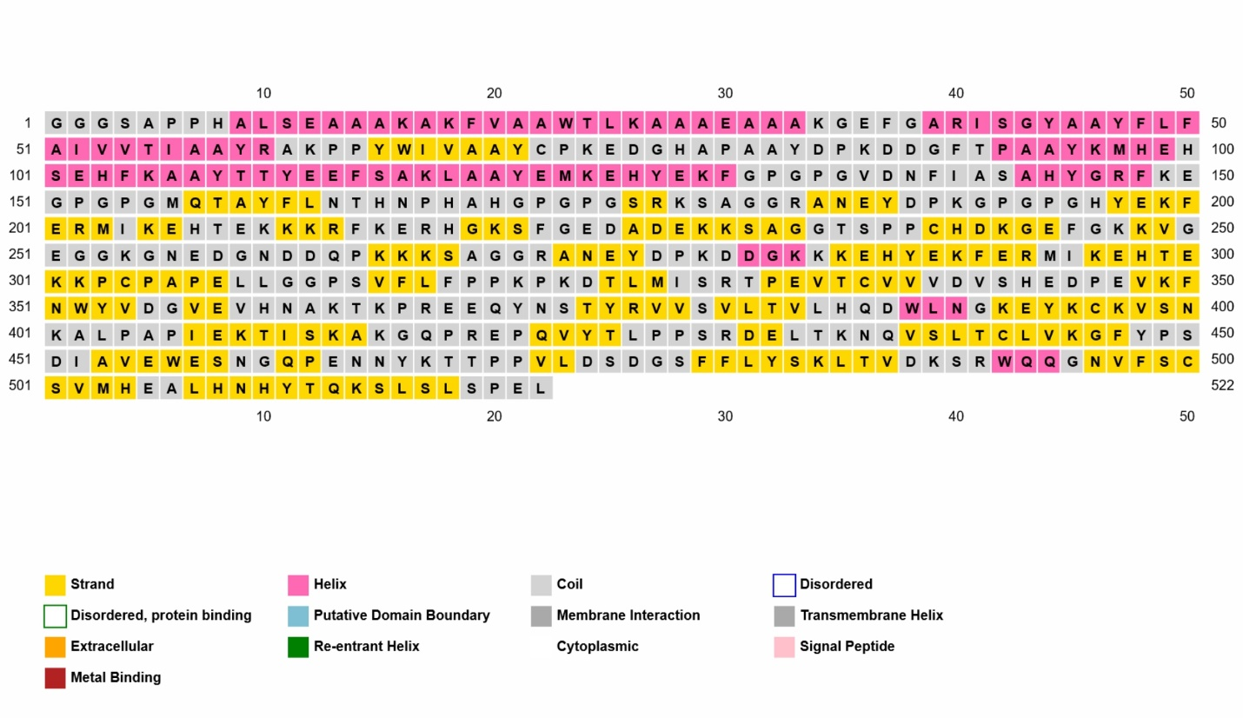**Fig. S1.** Secondary structure prediction to linear MEV-Fc sequence by PSIPRED server

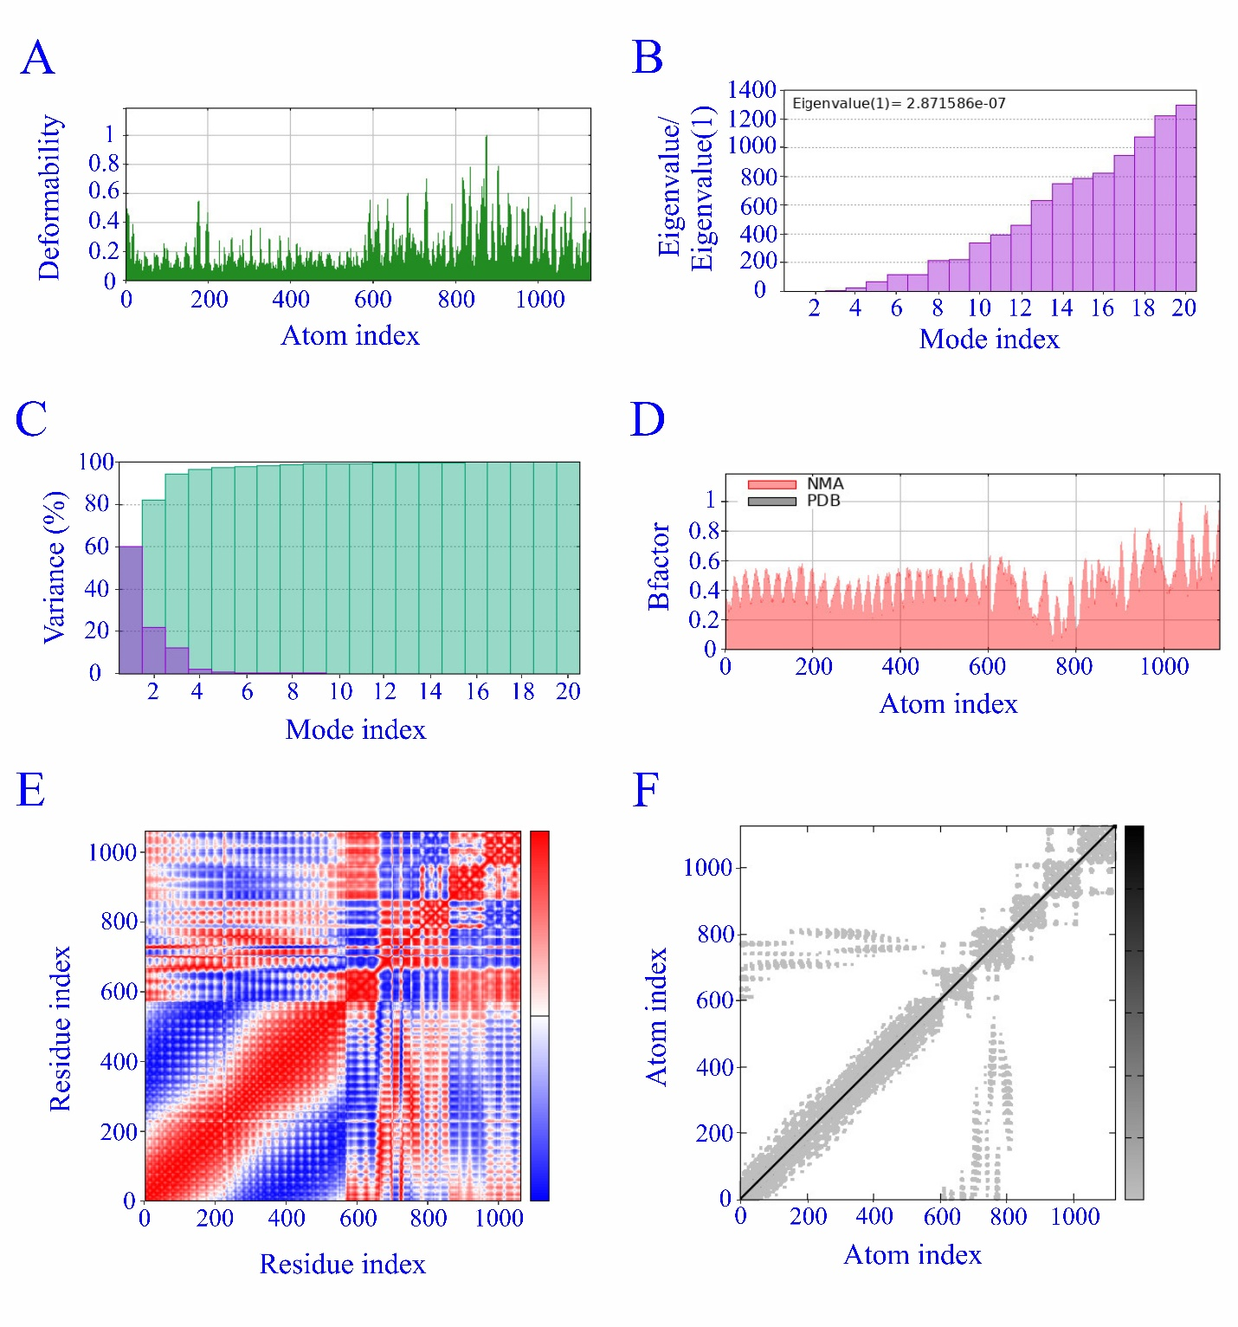**Fig. S2.** The findings of the molecular dynamics simulation of MEV-Fc-TLR4